3rd 9 Weeks Comprehensive Unit Assessment - Key
- D
- C
- D
- D
- A
- A
- B
- B
- A
- C
- D
- D
- A
- B
- D
- A
- D
- C
- C
- A
- B
- A
- C
- B
- A
- C
- D
- A
- C
- A
- A
- B
- B
- B
- C
- B
- A
- B
- D
- A

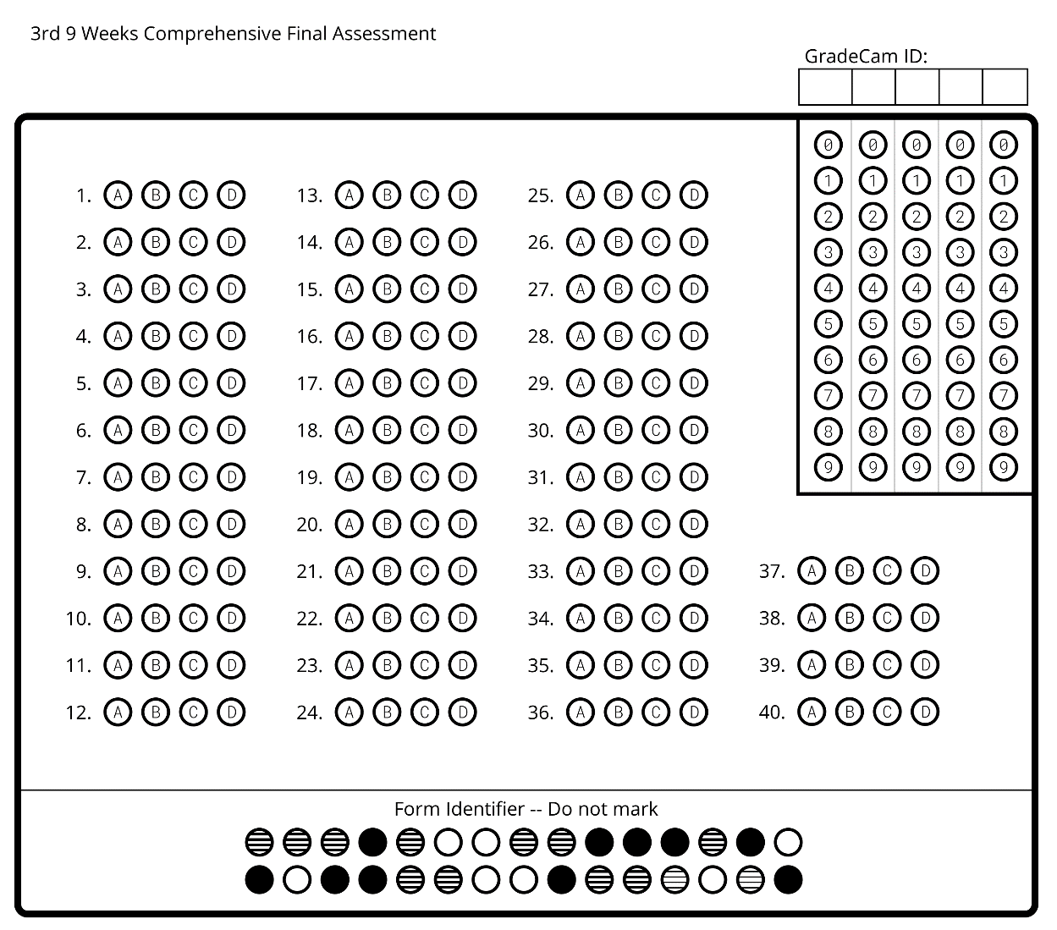
Name:_________________________
Date:__________________________
Period:_________________________

Name:_________________________
Date:__________________________
Period:_________________________

